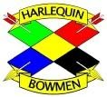
Harlequin Bowmen Clout Weekend incorporating the Berkshire Archery Association Clout Championships
Saturday 22nd and Sunday 23rd June 2024

Rounds: Saturday: One-way Double Metric Clout shot in two details
Sunday: One-way Double GNAS Clout shot in two details

Both days are Tassel Status and Record Status

Entry fee: Seniors: Both days £15; Single day £10 Juniors: FREE!

Timings: Registration & bow inspection from 9:30 am (please bring AGB cards)
Saturday: Assembly at 10:30 am, sighters 10:45 am
Sunday: Assembly at 10:30 am, sighters 10:45 am

Venue: Didcot Girls School, Manor Crescent, Didcot, OX11 7AJ

Judges: Andy Turner (JIC), Graham Pink, Siobhan Tyson

Lord Patron: (TBC)

Bowstyles: Recurve, Compound, Barebow, Longbow, AFB/Traditional

Dress code: Being a record status shoot, please dress according to rule 307.
Awards: Medals awarded for all archers placed 1st to 3rd in each category each day
SATURDAY: BAA Awards to BAA archers, with separate awards to visitors
SUNDAY: No separate awards for BAA/visitors.
1st place ‘weekend’ award for each category including the Mick Baines Recurve awards and Team* awards: Senior Team- Three 18+ y.o. from same club; Junior Team: Two archers <18 y.o. from same club.
*- archers must shoot both days; adjustment tables normalised to a ‘recurve’ scale

Catering: On-site catering will be available…details to be confirmed

Entries to: ONLINE: via www.harlequinbowmen.org.uk then ‘Open Competitions’
Email: chairman@harlequinbowmen.org.uk.
Postal: Paul Comina, 12 The Crescent, OXON, OX11 9JY

Closing date: Saturday 15th June 2023
Entries after this date will depend on space available or cancellations

Juniors: Juniors under 18 must be accompanied by a responsible adult at all times

Photography: In accordance with the GNAS Protection of Children & Vulnerable Adults Policy, those who wish to take photographs must register with the TO on the day.

The organiser, Harlequin Bowmen, Berkshire Archery Association & Didcot Girls’ School cannot accept responsibility for any loss, damage or injury howsoever caused

ENTRY FORM
Fill out and return this form by email to chairman@harlequinbowmen.org.uk or enter online at: http://www.harlequinbowmen.org.uk
Payment by BACS: Reference ‘Clout *SURNAME*’, using Account Name: Harlequin Bowmen; Account No.: 00097432; Sort Code: 30-93-93. Please email to confirm payment made.
ROUNDS: Awards for archers shooting their expected rounds by age, bow type and gender as per the new AGB rules 705 and 707:
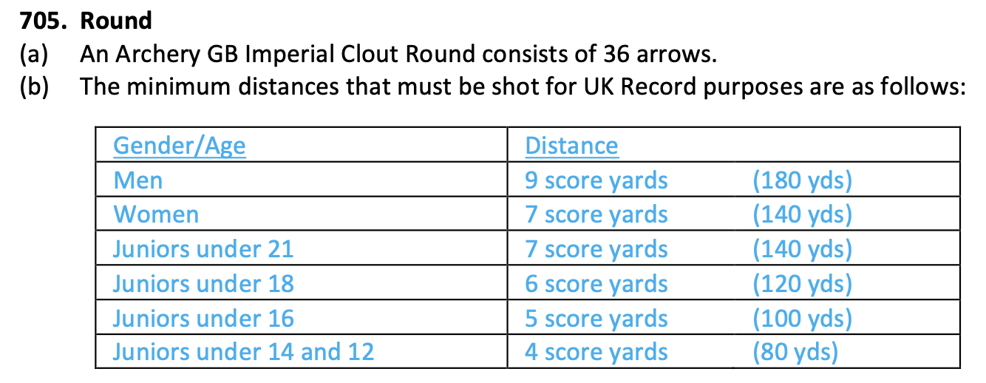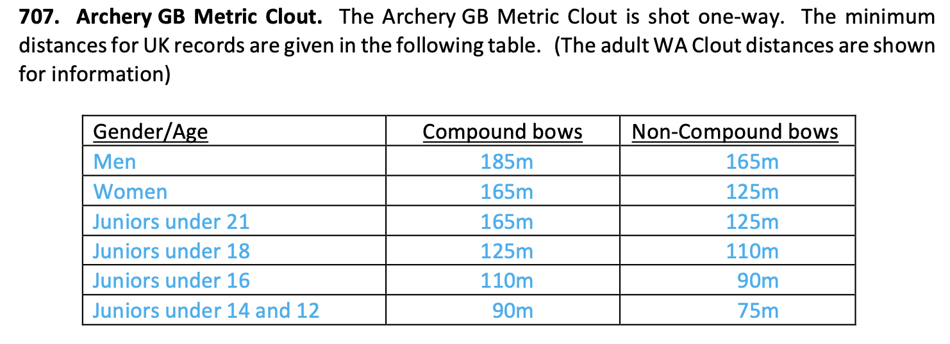

Name of Archer  (please print) | Archery GB No. | Male/  Female  M/F | Age Group  50+, senior, U21, U18, U16, U14, U12  (ALL: include D.O.B) | SATURDAY  Metric distance | SATURDAY  Bow style  R BB  LB C Trad | SATURDAY  BAA archer  or visitor? | SUNDAY  GNAS distance | SUNDAY  Bow style  R BB  LB C Trad | TOTAL FEE  Juniors: Free  Seniors:  Both days: £15  Single day £10

Club Name: | Total fee to be paid  £
Sender’s Name and address and number: | E-mail address for target lists and results (please print clearly):
Signature to confirm all entered via this form have received clout instruction: | Target lists and results will be available on Harlequin Bowmen’s website: www.harlequinbowmen.org.uk

We collect personal data for the purposes of running events only. It will be stored solely for the purpose of running this event but will never be shared without your permission.

If you would like us to contact you directly about our future events in the next 12 months please tick here:

A word on age categories from AGB:
